Public Health Schools Opportunities

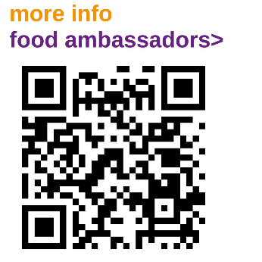
School Food Ambassadors
New project for pupils to feed into the school meals system, reduce food waste and improve the school dining experience. Supported by a toolkit and PowerPoint lesson plans. All resources available on Padlet. Schools that set up a School Food Ambassador Programme this year will receive £100 to support the work.
More info on BEEM or email PH.schools@brighton-hove.gov.uk to sign up

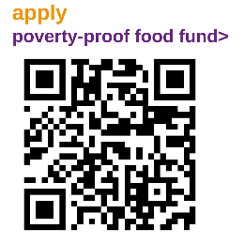
Poverty proofing food fund
Limited fund to support sustainable initiatives which address food poverty and increase access to nutritious food for students in financial hardship. All schools can apply for up to £400.
Apply on BEEM, or email PH.Schools@brighton-hove.gov.uk for more information.

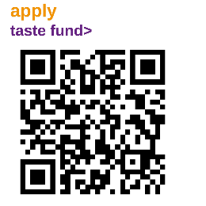
Taste Fund
Small grants for schools to purchase fruit and vegetables for projects that encourage pupils to taste and have positive experiences of fruit, vegetables and other plant-based nutritious foods. Open to all maintained schools and academies in Brighton and Hove, up to a maximum of £100 for each school.
Apply on BEEM, or email PH.Schools@brighton-hove.gov.uk for more information.

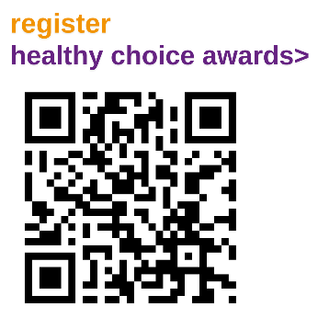
Healthy Choice Breakfast Club Awards (Primary)
Awards to recognise schools who are supporting children to make healthy choices at breakfast clubs. Blue, gold and platinum awards available based on nutrition, physical activity and tooth brushing facilities.
Apply on BEEM, or email PH.Schools@brighton-hove.gov.uk for more information.


Healthy eating resources
There is a wealth of healthy eating resources available online including recipe booklets, School Food Ambassadors teaching resources, Healthy Choice Breakfast Club awards guidance and food and drink template policies.
Visit Padlet, or email PH.Schools@brighton-hove.gov.uk for more information.

