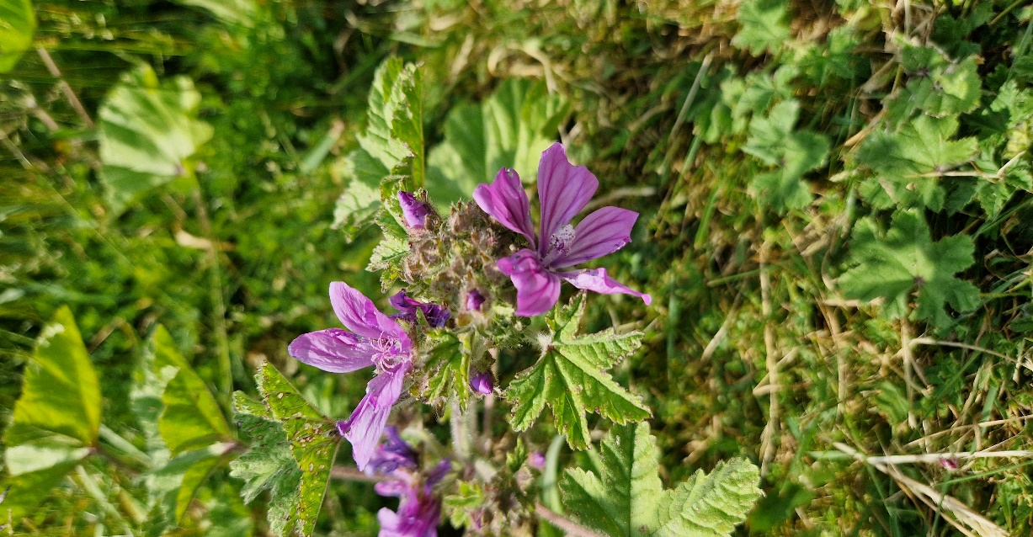
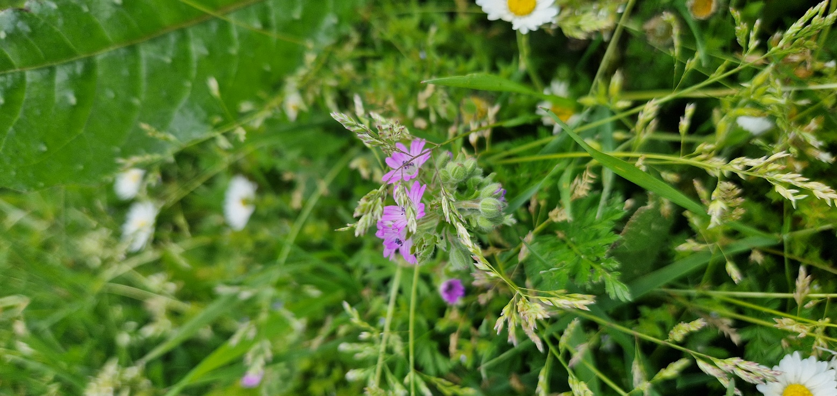

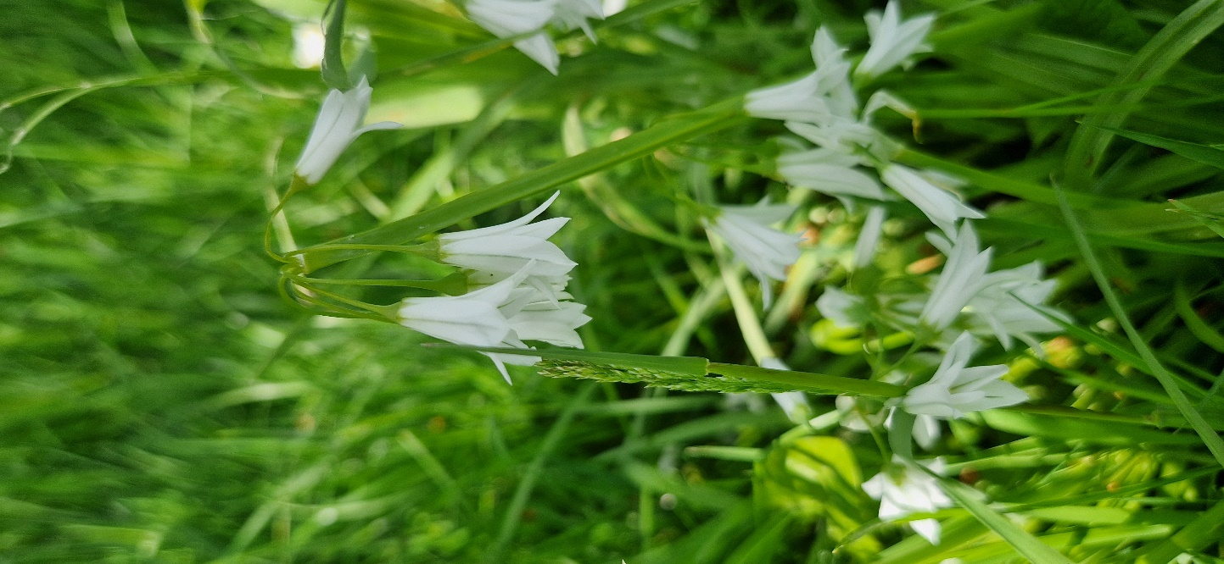
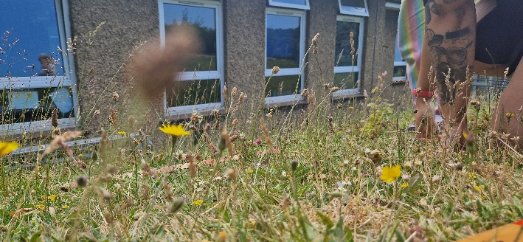

No Mow May 2023

Presented by Seniz Mustafa, Lauren Bentley and Charlotte Williams on behalf of Brighton & Hove City Council

Summary of findings
The observation period for this study was from the 16th of May to the 9th of June, 2023. At each site, quadrats were used to establish the presence and composition of species. At all sites, an improvement in species composition and growth was found. Including species that were found to improve soil quality, moisture and increase nutrient availability for other surrounding plants. Balfour found new species, such as chickweed, had established, and over half of the species observed had increased in their composition. At Goldstone, a large increase in plant height was found, with detrimental species being replaced by more beneficial species such as feather moss and yarrow. St. John the Baptist also saw new species, such as field forget-me-nots and dandelions, that are beneficial to the soil.
Balfour
At Balfour, we saw some change present, however, this was limited to its potential due to the mowing of part of the lawn, which meant that plant height averaged 16 cm at the end of this study. In this large lawn area, there was an increase in the presence of daisies and white clover, and the bare ground seen initially had been covered by vegetation by the end of this study. In the second area, located closer to a building and other areas left wild for flowers, had seen more success. A complete decline in the dead moss and dead grass was initially observed, and plants such as dandelions, chickweed and speedwell had been established by the end of June. Chickweed is beneficial as it is a source of food for small bird species such as the chaffinch and insects such as ground beetles. Overall, 11 different plant species had established or increased their percentage cover. Additional species observed at the end of this study included horse chestnut and sticky weed.
Species diversity change
 |  | Overall
Quadrat | Species/feature | Percentage change (%)
1 | Bare ground | -5
 | Broad-leaved grass | -5
 | Daisy | +3
 | White clover | +18
2  2 | Birds foot trefoil | -1
 | Black medic | +0
 | Cinque foil | -1
 | Buttercup | +2
 | Daisy | +12
 | Dandelion | +5
 | Chickweed | +7
 | Field madder | +5
 | Fine grass | +2
 | Grass (dead) | -29
 | Hairy hawkbit | -20
 | Moss (dead) | -10
 | Plantain | +13
 | Red clover | -3
 | Speedwell | +1
 | Yarrow | +17
Change in number of species = |  | -3
Percentage of species that increased = |  | 52.4%

Photographic comparisons
Before | After
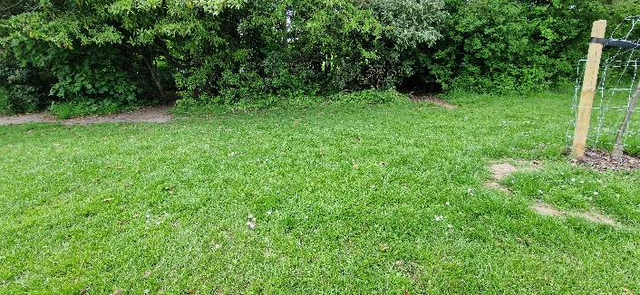
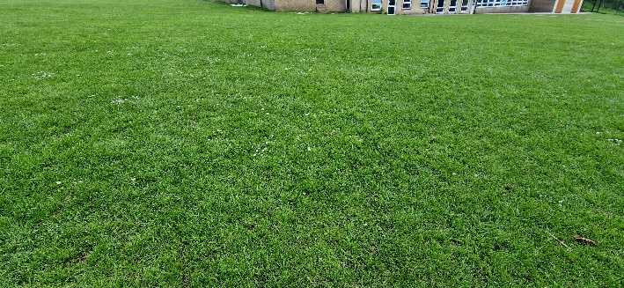 | 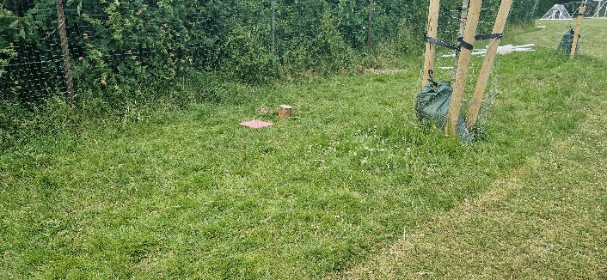
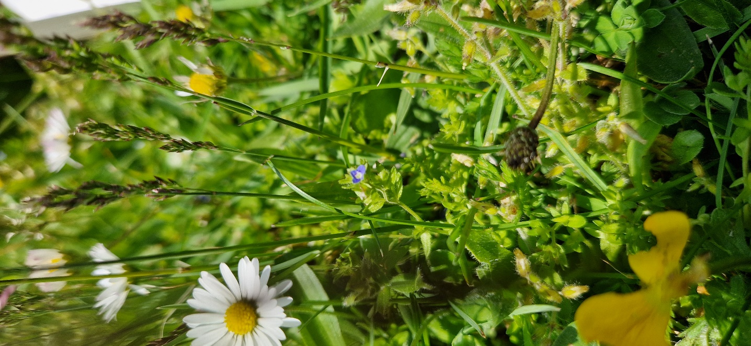 | 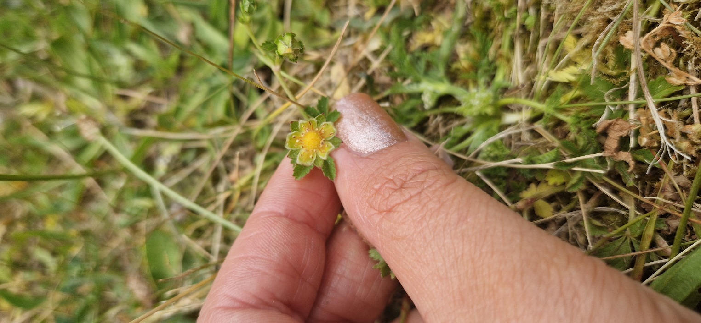

Goldstone
Goldstone saw the largest transformation due to the area having good access to sunlight which allowed plants, on average, to grow to 70.2 cm. Initially, there was the presence of three-cornered garlic (see images below), which is known to outcompete native plants and decrease biodiversity. This plant was not observed at the end of this study, which could be due to the extensive sunlight it was exposed to, being a plant that prefers partial shade. It was found that fine-leaved grass replaced broad-leaved grass and grew to great lengths. The establishment of the feather moss will allow the soil beneath to maintain its moisture, enabling surrounding plants to thrive. Additionally, yarrow was observed at the end of the study, which may be beneficial to other plants as it improves the quality of soil by adding minerals such as potassium, calcium and magnesium to its surface.
Species diversity change
 |  | Overall
Quadrat | Species/feature | Percentage change (%)
1 | Broad-leaved grass | -31
 | Cut-leaved crane’s bill | -7
 | Daisy | +4
 | Dove’s foot crane’s bill | +2
 | Fine-leaved grass | +25
 | Feather moss | +10
 | Plantain | +0
 | Spotted medic | -9
 | Clover | +5
Change in number of species = |  | +1
Percentage of species that increased = |  | 55.6%

Photographic comparisons
Before |  | After
 | 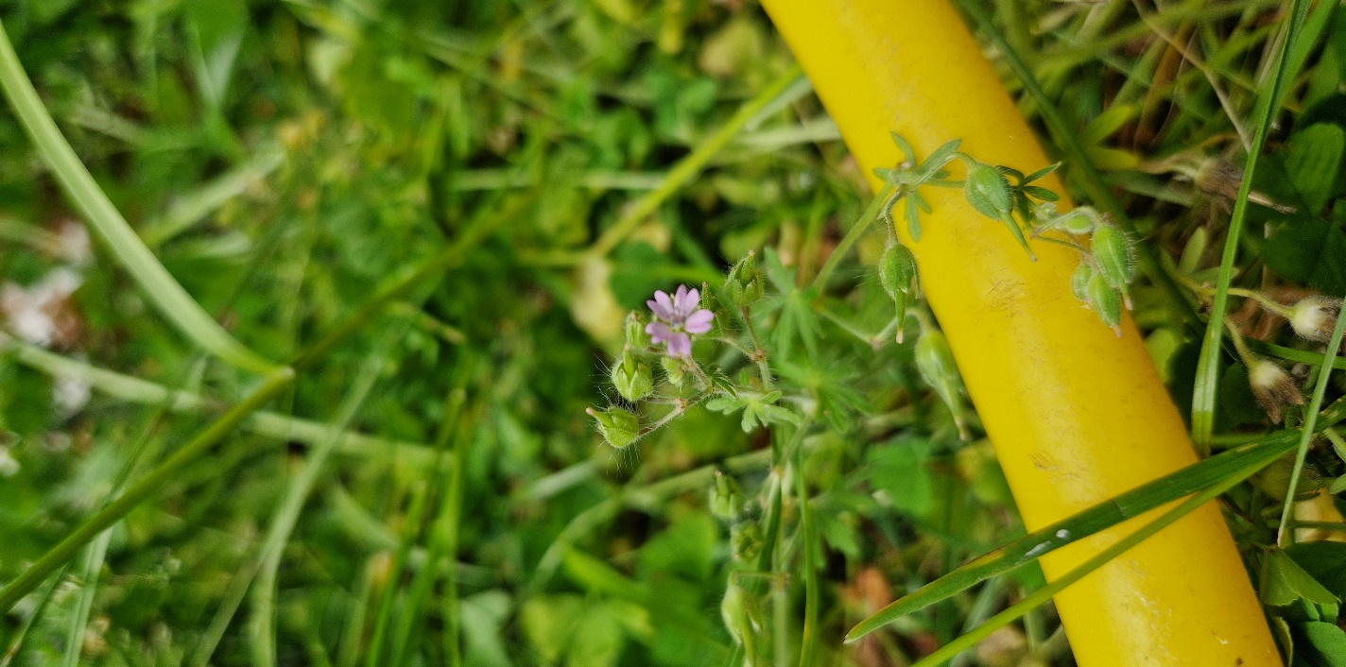
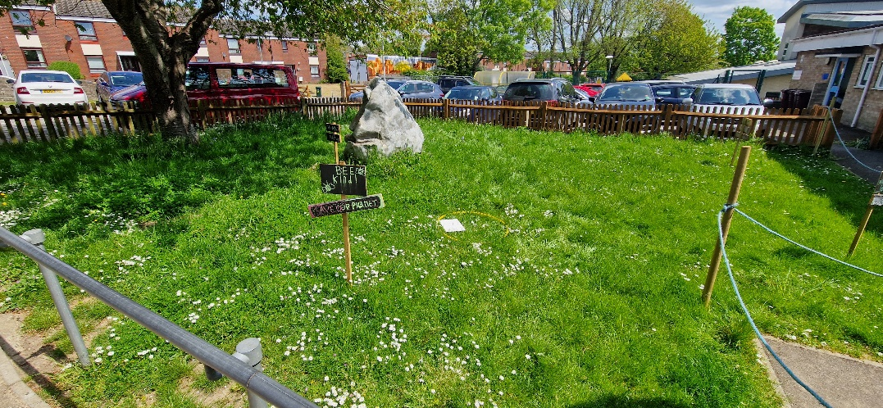 | 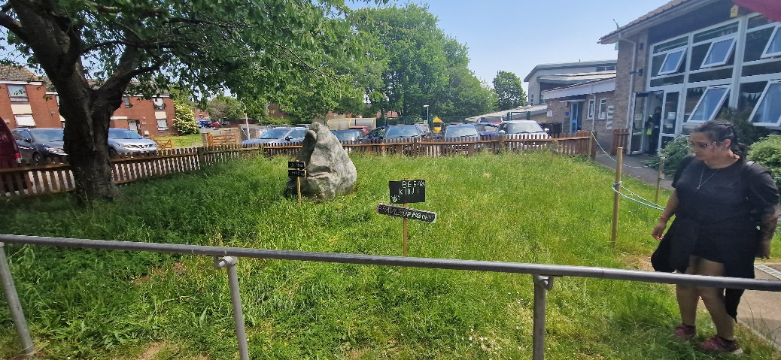
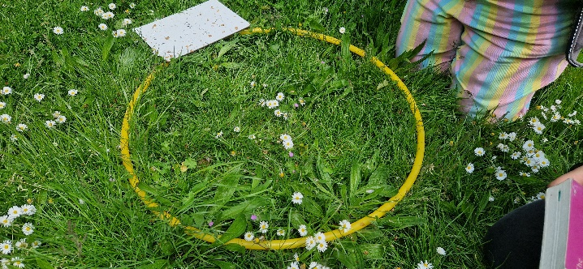 | 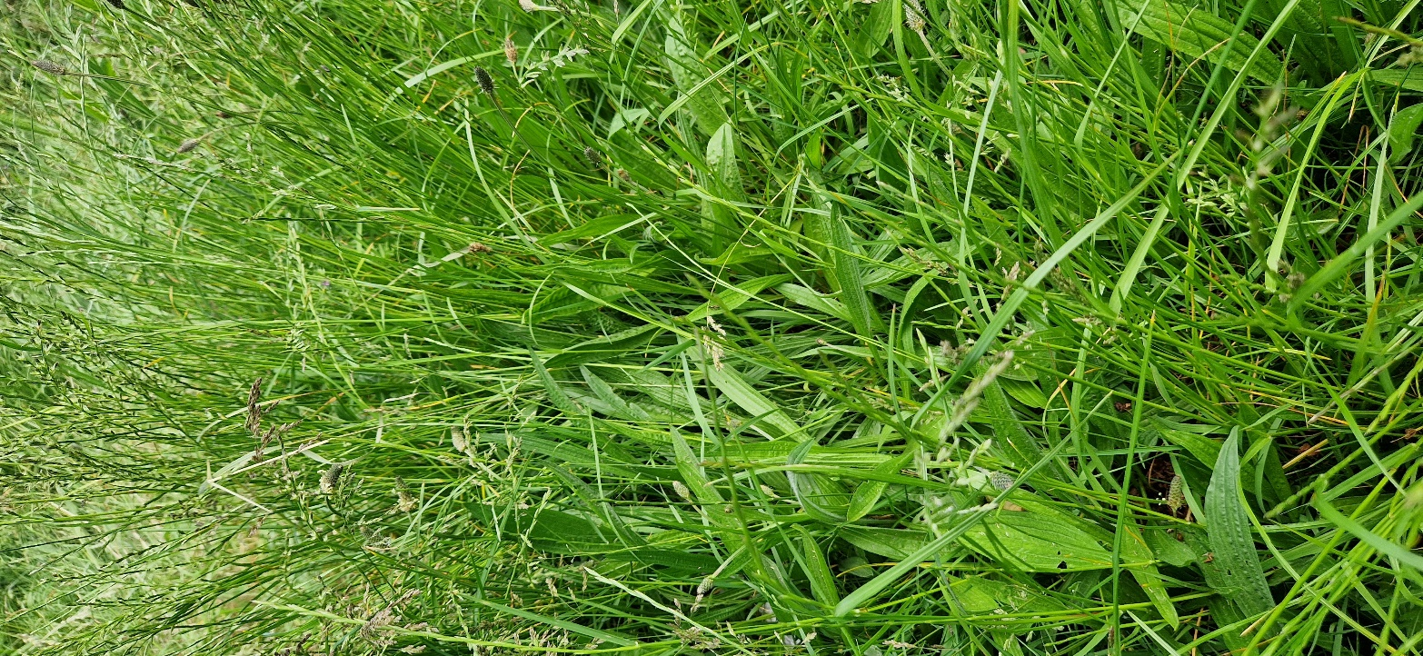

St. John the Baptist
There was the largest change in composition at St. John the Baptist, with fewer species found at the end of the study, including an absence of broad-leaved grass in addition to meadow grass and changing forget me not. Similarly, to Goldstone, the broad-leaved grass was replaced by fine-leaved grass among the taller plants, with an average plant height of 23.7 New species included the field forget-me-not, which suggests the soil may be more moist as this is where this species flourishes and will enable other plants to grow well. Additionally, dandelion had established, which improves soil by aerating the soil with its roots that pull nutrients from the deeper areas of soil and make minerals such as calcium more available for other plants.
Species diversity change
 |  | Overall
Quadrat | Species/feature | Percentage change (%)
1 | Black medic | -3
 | Bristly oxtongue | +7
 | Broad-leaved grass | -19
 | Buttercup | -5
 | Changling forget-me-not | -15
 | Clover | +13
 | Cut-leaved crane’s bill | -1
 | Daisy | +2
 | Dandelion | +6
 | Field forget-me-not | +6
 | Field madder | +1
 | Fine-leaved grass | +32
 | Fleabane | -1
 | Meadow grass | -15
 | Plantain | -5
 | Sow thistle | +1
 | Speedwell | +2
 | Willow herb | -1
 | Yarrow | -5
Change in number of species = |  | -5
Percentage of species that increased = |  | 47.4%

Photographic comparisons
Before | After
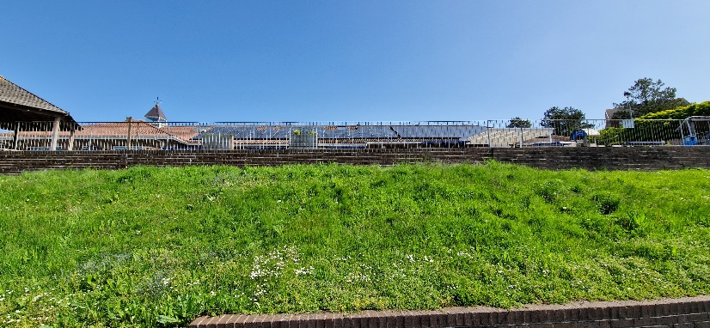 | 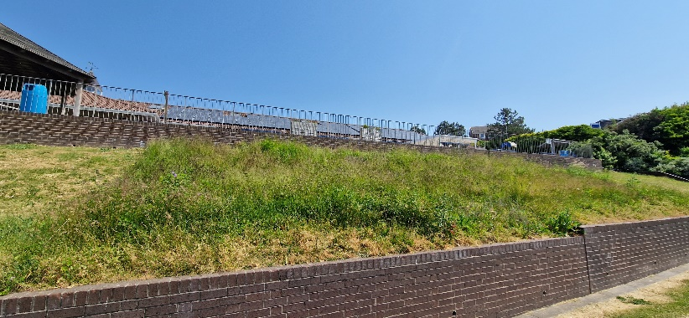
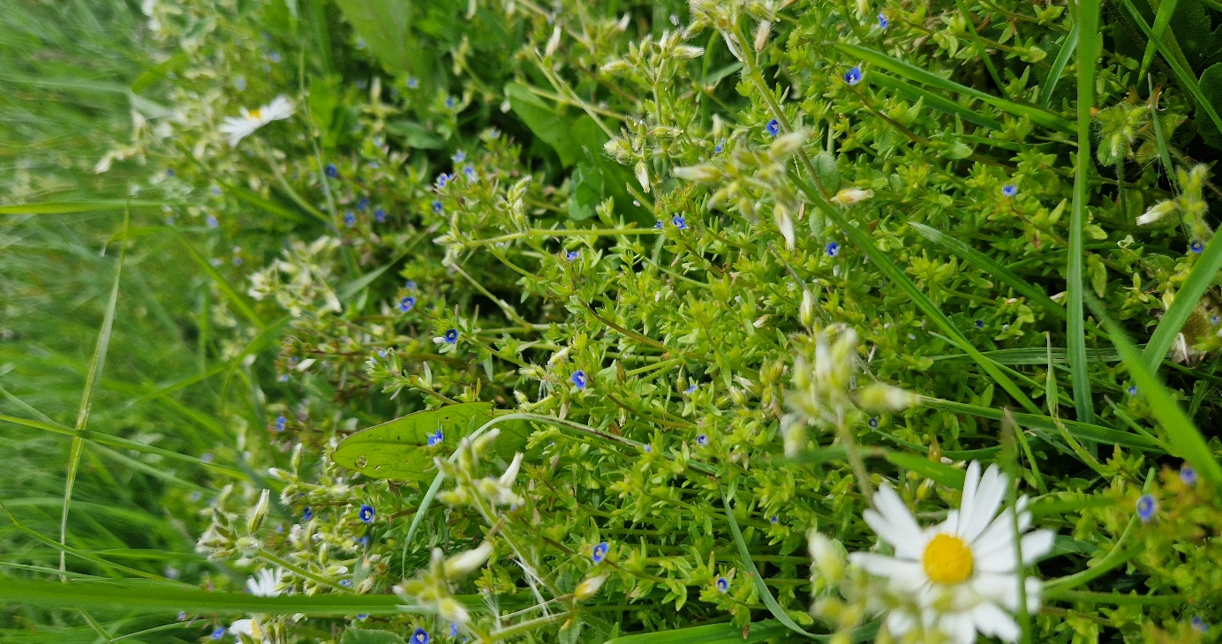 | 